Chapter 4, Problem 57.

Obtain the Thevenin and Norton equivalent circuits at the terminals a-b for the circuit in Fig. 4.123.

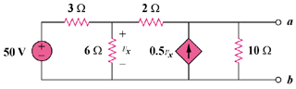

Figure 4.123
For Prob. 4.57.

